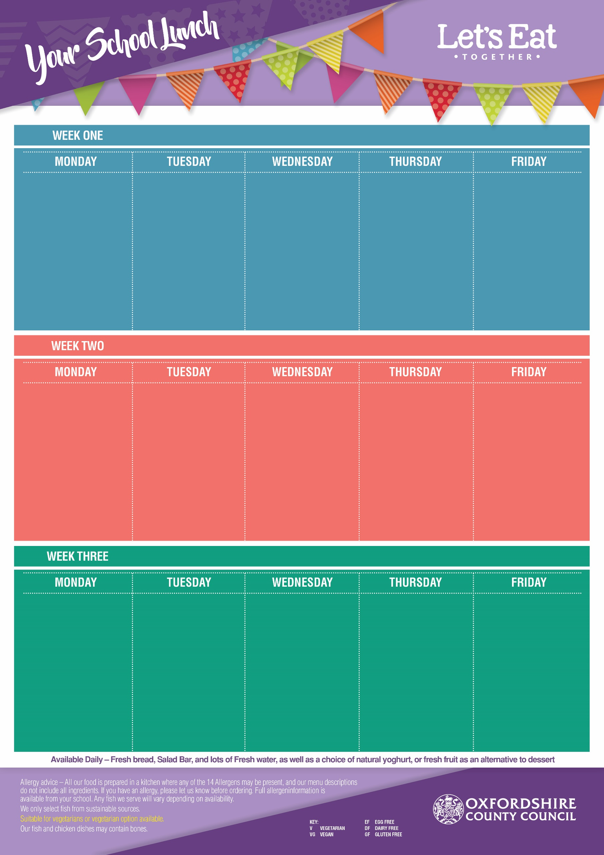
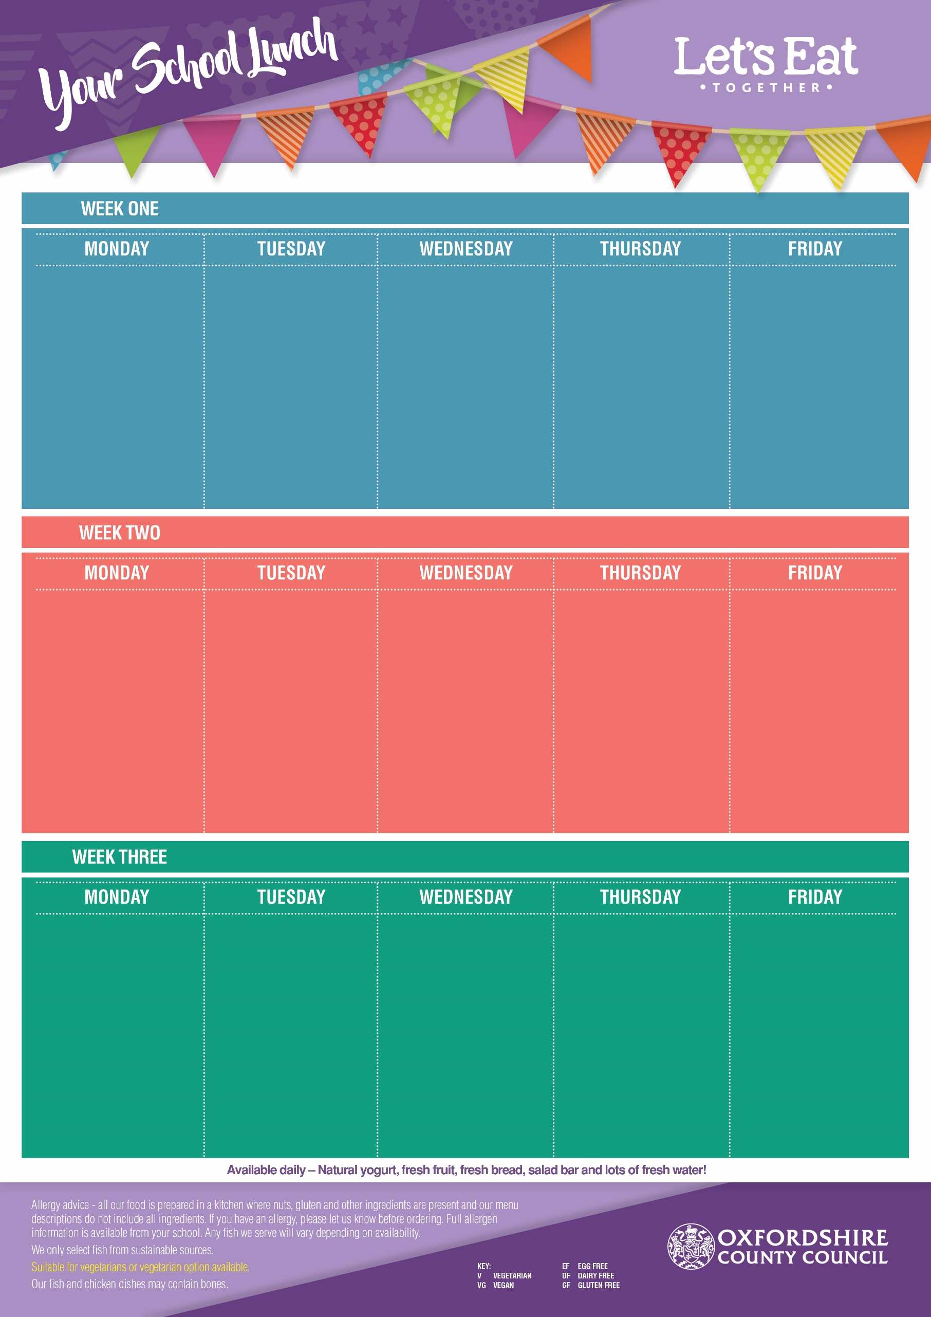
Roast Chicken Breast
(GF, DF, EF)
Quorn Roast
(V, GF)
Baked Jacket Potato with Baked Beans (VG, GF)

Roast Potatoes,
Yorkshire Pudding,
Cauliflower & Peas

Cherry Biscuit
(V, EF)

Flipper Dippers (DF, EF)
Veggie Samosa’s (VG)
Egg Mayo & Lettuce Wrap (V, DF)
Baked Jacket Potato with Cheese (V, GF, EF) or Baked Beans (VG, GF)
French Fries or Pasta
Baked Beans
or Sweetcorn
Strawberry Ice Cream
(V, GF, EF)
with Melon

Margherita Pizza
(Cheese & Tomato) (V, EF)
Sweet Potato & Chickpea Curry with Rice (V, GF, EF)

Baked Jacket Potato with Cheese (V, GF, EF)

Sweetcorn
& Baked Beans

Vanilla Sponge
Cake (V, DF)

20th April 11th May, 8th June, 29th June, 20th July, 7th Sept, 28th Sept, 19th Oct
Roast Loin of Pork
(GF, DF, EF)
Quorn Roast (V, GF)
Baked Jacket Potato with Cheese (V, GF, EF) or Baked Beans (VG, GF)

Yorkshire Pudding, Roast Potatoes & Gravy
Carrots & Cabbage

Shortbread (V, EF, DF)
with an Orange Wedge

Meatballs in a Tomato Sauce (GF, DF, EF)
Veggie Meatballs in a Tomato Sauce
(VG, GF,)
Baked Jacket Potato with Cheese (V, GF, EF) or Baked Beans (VG, GF)

Pasta,
Peas & Broccoli

Ginger Biscuit
(V, EF)

Pork Sausages with Gravy
(DF, EF)
Veggie Sausage with Gravy (VG, GF)

Baked Jacket Potato with Cheese (V, GF, EF) or
Baked Beans (VG, GF)

Mashed Potatoes (GF, EF)
Carrots & Cauliflower

Crunchy Cornflake Cookie
(EF, DF)

Chicken & Leek Pie
with New Potatoes
(DF, EF)
Sweet & Sour Veggie Noodles (V, DF)
Baked Jacket Potato with Cheese (V, GF, EF) or Baked Beans (VG, GF)

Vegetable Medley & Broccoli

Cinnamon Cookie
(V, EF)

Margherita Pizza
(Cheese & Tomato) (V, EF)
Vegetable & Bean Chilli with Rice (VG)
Baked Jacket Potato with Baked Beans (VG, GF)

Sweetcorn &
Baked Beans

Lemon Oat Cookie
(V, EF, DF)
& Raisins

Beef Bolognese with Pasta (EF, DF)
Veggie Bolognese with Pasta (VG)
Baked Jacket Potato with
Cheese (V, GF, EF) or Baked Beans (VG, GF)

Carrots & Green Beans

Iced Sprinkle Cake
(V, DF)

Chicken Nuggets (Ef, DF)
Veggie Sausage Roll (V, EF)
Baked Jacket Potato with Cheese (V, GF, EF) or Baked Beans (VG, GF)

Chips or Pasta
Peas &
Baked Beans

Vanilla Ice Cream
(V, GF, EF)
with Pineapple

Creamy Chicken Risotto
(GF, EF)
Veggie Sausage Pasta Bake (V, EF)
Baked Jacket Potato with Cheese (V, GF, EF) or Baked Beans (VG, GF)

Peas & Green Beans

Sultana & Syrup
Cookie
(V, EF)

27th April 18th May, 15th June, 6th July, 14th Sept, 5th Oct
13th April, 4th May, 1st June, 22nd June, 13th July, 31st Aug, 2nd Sept, 12th Oct
Roast Gammon (GF, EF, DF)
Vegetarian Quorn Roast
(V, GF)
Baked Jacket Potato with Cheese (V, GF, EF)

Roast Potatoes & Yorkshire Pudding with Gravy

Savoy Cabbage
& Peas

Banana Cake
(V, EF)

Margherita Pizza
(Cheese & Tomato) (V, EF)
Spinach & Pepper Pasta (VG)
Baked Jacket Potato with Cheese (V, GF, EF)

Sweetcorn &
Baked Beans

Melting Moment
(V, DF, EF)
with Mandarins

Fish Fingers (DF, EF)
Cream Cheese & Broccoli Pinwheel (V, EF)
Baked Jacket Potato with Cheese (V, GF, EF)
(VG)

Chips or Pasta
Peas &
Baked Beans

Strawberry Jelly
(V, GF, DF, EF)
with Peaches

Chicken Korma
with Rice (EF, GF)
Mac ’n’ Cheese (V, EF)

Baked Jacket Potato with Cheese (V, GF, EF) or Baked Beans (VG, GF)

Carrots &
Sweetcorn

Rock Cake
(V)

