Y4 Bounty Spellings – Summer Term 1 2026
Week 1/ Learn the following spellings to be tested on:  Tues 21st April  everybody  eye  fast  father | Week 2/ Learn the following spellings to be tested on:  Tues 28th April  find  floor  gold  grass | Week 3/ Test: Tues 5th May  steak  great  half  hold
Week 4/ Test: Monday 12th May  hour  improve  kind  last | Week 5/ Test: Tues 19th May  Revisit words from the last 4 weeks and see if you can remember them.

Y4 Bounty Spellings– Summer Term 2 2026 – After half term!
Week 1/ Test: Tues 9th June  move  Mr  Mrs  old | Week 2/ Test: Tues 16^{h} June  only  parents  pass  past | Week 3/ Test: Tues 23th June/  path  people  plant  poor | Week 4/ Test: Tues 30th June  pretty  prove  should  steak
Week 5/ Test: Tues 7th July  sugar  sure  told  water | Week 6/ Test: Tues 14th July  many  mind  money  most | Spellings will be tested every Tuesday morning and the new spelling rule taught for the following week.  Although spellings will be learnt in the classroom, extra practice at home is essential for children to be able to memorise them.  Children who gain full marks in their spelling test each week will be given Dojo points.

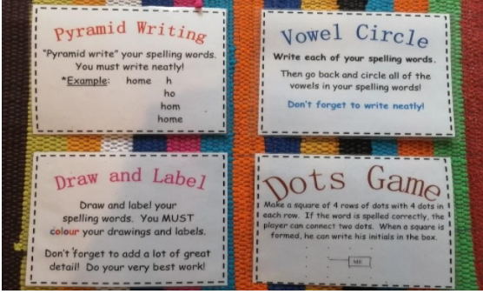

You could try one of these methods to learn your spellings!

