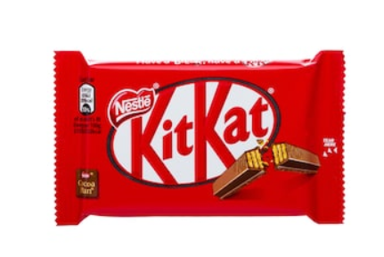
Y4 Kit Kat Spellings – Summer Term 1 April 2026 – No spelling test first week back
Week 1/ Learn the following spellings to be tested on:  Tues 21st April/ adding the prefix inter (meaning ‘between’ or ‘among’)  interact  interfere  intercity  international  intermediate  internet  intergalactic  interrupt  intervene  interlude | Week 2/ Learn the following spellings to be tested on:  Tuesday 28th April / adding the prefix auto – meaning self or own and anti – meaning against  anticlockwise  antiseptic  antisocial  antibiotic  autograph  automatic  autobiography  autopilot  autocorrect  autocue
Week 3/ Test: Tues 5th May / adding prefix ex meaning out  exit  extend  explode  excursion  exchange  export  exclaim  expel  external  exterior | Week 4/ Test: Tues 12th May / words ending in ar/er  calendar  grammar  regular  particular  peculiar  popular  consider  remember  quarter  integer
Week 5/ Test: Tues 19th May
Revisit the spellings from the last 4 weeks and see if you can remember them. The test will be on a random selection of these words.

Y4 Kit Kat Spellings – Summer Term 2 2026 – No spelling test first week back
Week 1/ Test: Tuesday 9th June / adding the suffix ‘ous’/no change in root word or no definitive root word  dangerous  poisonous  hazardous  momentous  scandalous  enormous  jealous  serious  obvious  gorgeous | Week 2/ Test: Tues 16th June/ adding suffix ous  various  furious  mysterious  humorous  glamorous  nervous  ridiculous  adventurous  courageous  outrageous
Week 3/ Test: Tues 23th June/ Adverbials of frequency and possibility  regularly  occasionally  frequently  usually  rarely  perhaps  maybe  certainly  possibly  probably | Week 4/ Test: Tues 30th June / Adverbials of manner  awkwardly  frantically  curiously  obediently  carefully  rapidly  unexpectedly  deliberately  hurriedly  reluctantly
Week 5/ Test Tues 7th July/ Year 4 statutory spellings/  sentence  experience  recent  certain  special  different  difficult  knowledge  decide  accident | Week 6/ Test : Tues 14th July / year 4 statutory spellings challenge words  question  mention  possession  position  opposite  potatoes  favourite  thought  caught  naughty

