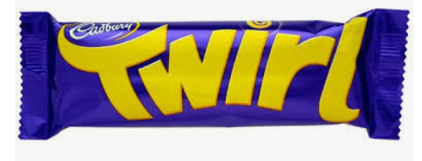
Y4 Twirl Spellings – Summer Term 1 April 2026– No spelling test first week back
Week 1/ Learn the following spellings to be tested on:  Tues 21st April/ adding the prefix inter (meaning ‘between’ or ‘among’)  interact  interfere  intercity  international  internet  interrupt | Week 2/ Learn the following spellings to be tested on:  Tuesday 28th April / adding the prefix auto – meaning self or own and anti – meaning against  anticlockwise  antisocial  antibiotic  autograph  automatic  autocorrect
Week 3/ Test: Tues 5th May / adding prefix ex meaning out  exit  extend  explode  exchange  export  external | Week 4/ Test: Tues 12th May / words ending in ar/er  calendar  grammar  regular  popular  remember  quarter
Week 5/ Test: Tues 19th May
Revisit the spellings from the last 4 weeks and see if you can remember them. The test will be on a random selection of these words.

Y4 Twirl Spellings – Summer Term 2 2026 – No spelling test first week back
Week 1/ Test: Tuesday 9th June / adding the suffix ‘ous’/no change in root word or no definitive root word  dangerous  poisonous  enormous  jealous  serious  gorgeous | Week 2/ Test: Tues 16^{h} June/ adding suffix ous  various  furious  mysterious  glamorous  nervous  ridiculous
Week 3/ Test: Tues 23th June/ Adverbials of frequency and possibility  regularly  usually  maybe  certainly  possibly  probably | Week 4/ Test: Tues 30th June/ Adverbials of manner/ five spellings this week  curiously  obediently  carefully  deliberately  reluctantly
Week 5/ Test Tues 7th July/ Year 4 statutory spellings/ LAST TEST OF YEAR 4!  sentence  experience  special  different  difficult  accident | Week 5/ Test Tues 14th July/ year 4 statutory spellings challenge words  question  position  opposite  potatoes  favourite  thought

