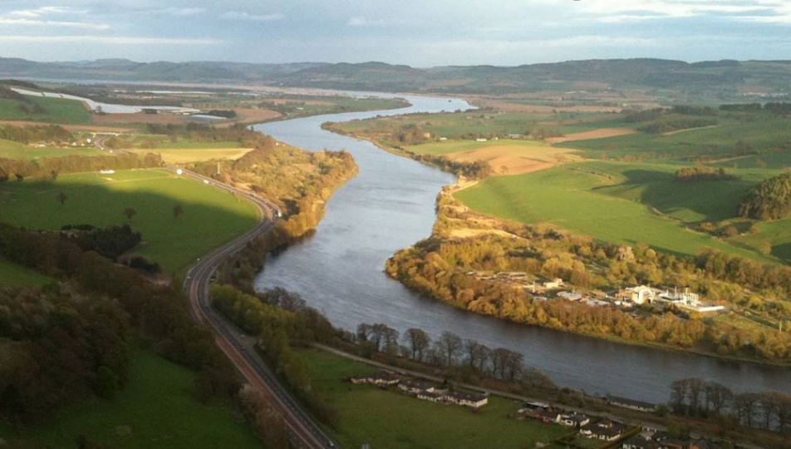
RE
Islam
What is the Qur’an and why do many Muslims try to learn it by heart?

PE
Swimming
Dance

This term we are linking DT with Science and Forest School, designing and making catapults

Computing
On-line Safety

How do rivers flow?
French
Months
Birthdays
Family

Geography
Rivers and local area
Looking at the affect the local river has in our area
Protecting our environment
The water cycle
Learning about major rivers of the world
English
This term we are finishing off our narrative based on the book Flood and then moving on to finding and presenting facts about a chosen river in the world

Maths
Mass and capacity
Fractions
Science
Forces and magnets
PSHE
Being my best

Music
Jazz

