Term 1
Art and D.T.
Painting and mixed media: Pre- historic painting
Structures: product packaging
R.E
Christianity
How are different people inspired by the teachings of Jesus?
We will be exploring some of the ways that Jesus taught his followers to live and behave and how this still inspires some people today.
Stone Age to Bronze and
PE
Monday - Dance
Friday- Tennis
English
Narrative writing using ‘Stone Age Boy’ by Satoshi Kitamura
Whole class guided reading and writing unit using ‘The Last Bear’ by Hannah Gold

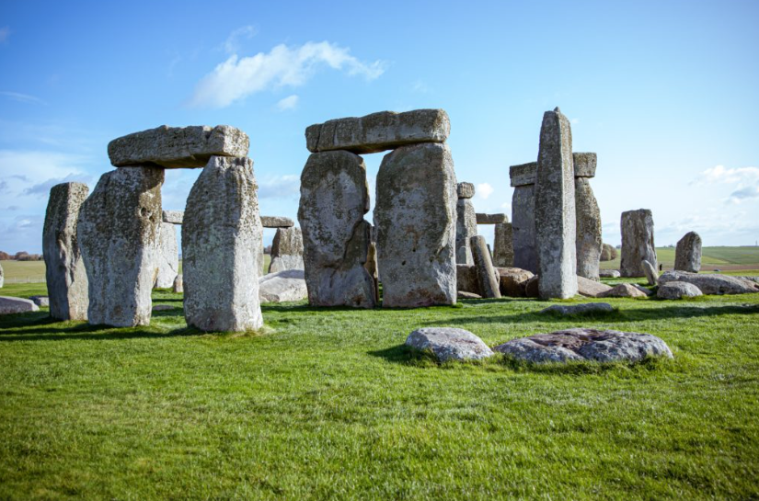
Iron Age
Maths
Place value
Addition and Subtraction

Geography
Are all settlements the same?
Science
Materials: Rocks and Soil

Computing
Networks and the internet
Journey inside a computer
Music
Ballads and developing singing techniques.

History
Would you have preferred to live in the Stone Age, Bronze Age or
Iron Age?

French
Greetings
How are you?
Classroom instructions
Numbers to 10
Phonics UN and ON

PSHE
Me and my relationships

