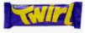Y4 Twirl Spellings – Autumn Term 1 2026
Week 1/ Learn the following spellings to be tested on:  Wed 9th September/ words with the aw spelt augh and au (4)  caught  naughty  taught  daughter | Week 2/ Learn the following spellings to be tested on:  Wed 16th September / adding the prefix ‘in’ meaning ‘not’ or ‘into’ or prefix ‘im’(4)  incorrect  incomplete  impossible  important | Week 3/ Test: Wed 23rd September / challenge words (4)  interest  experiment  favourite  potatoes
Week 4/ Test: Wed 30th Sept/ Homophone Pairs (4 spellings)  which/ witch  board/ bored | Week 5/ Test: Wed 7th October/ the ‘shun’ sounding ending spelt ‘sion’  division  decision  explosion  television | Week 6/ Test: Wed 14th October  Revisit your spellings for the last 5 weeks and check you remember them. The test will be a random selection from these.

Y4 Kit Kat Spellings – Autumn Term 2 2026– After half term!
Week 1/ Test: Wed 11th November/ Statutory Spelling Challenge Words for year 3/4  material  promise  opposite  minute | Week 2/ Test: Wed 18th November / Words with a shun sound spelt ssion (root word ends in ss or mit) (4)  discussion  possession  admission  impression | Week 3/ Test: Wed 25th  November/ Words with a shun sound spelt with tion (4)  action  question  mention  position | Week 4/ Test: Wed 2nd December/ Words with a shun shound spelt ‘cian’ (root word ends in c or cs/ (4)  musician  politician  electrician  magician
Week 5/ Test: Wed 9th December/ words with ‘ough’ to make long o, oo or or sound (4)  though  although  through  thought | Week 6/ Test: Wed 16th Dec  Revisit your spellings for the last 5 weeks and check you remember them. The test will be a random selection from these. | Spellings will be tested every Wednesday morning and then the new spelling rule will be taught for the next week.  Although spellings will be taught in the classroom, extra revision at home is essential for children to be able to memorise them.

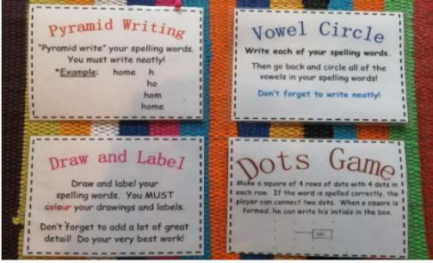You could try one of these methods to learn your spellings!

