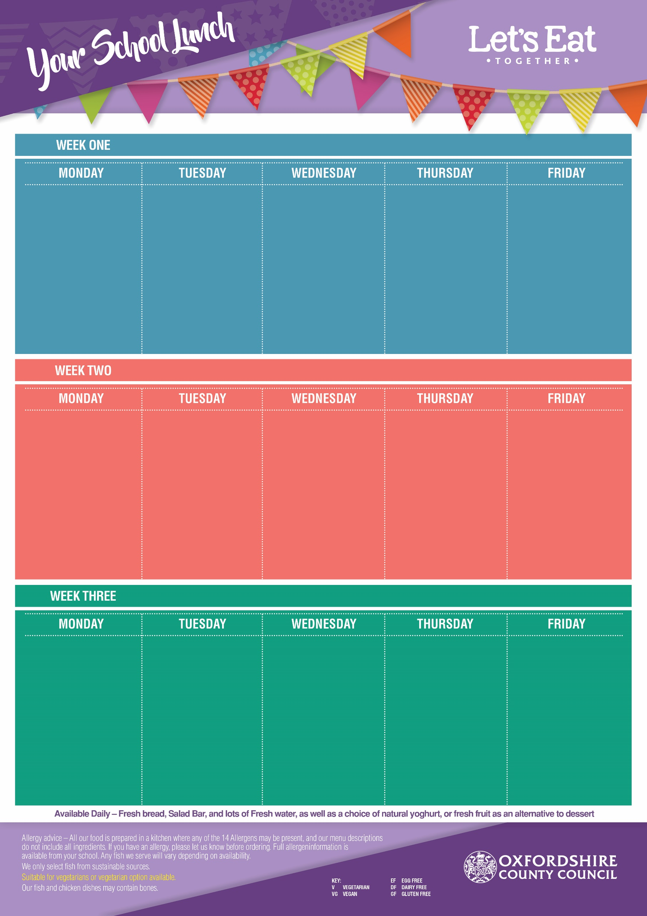
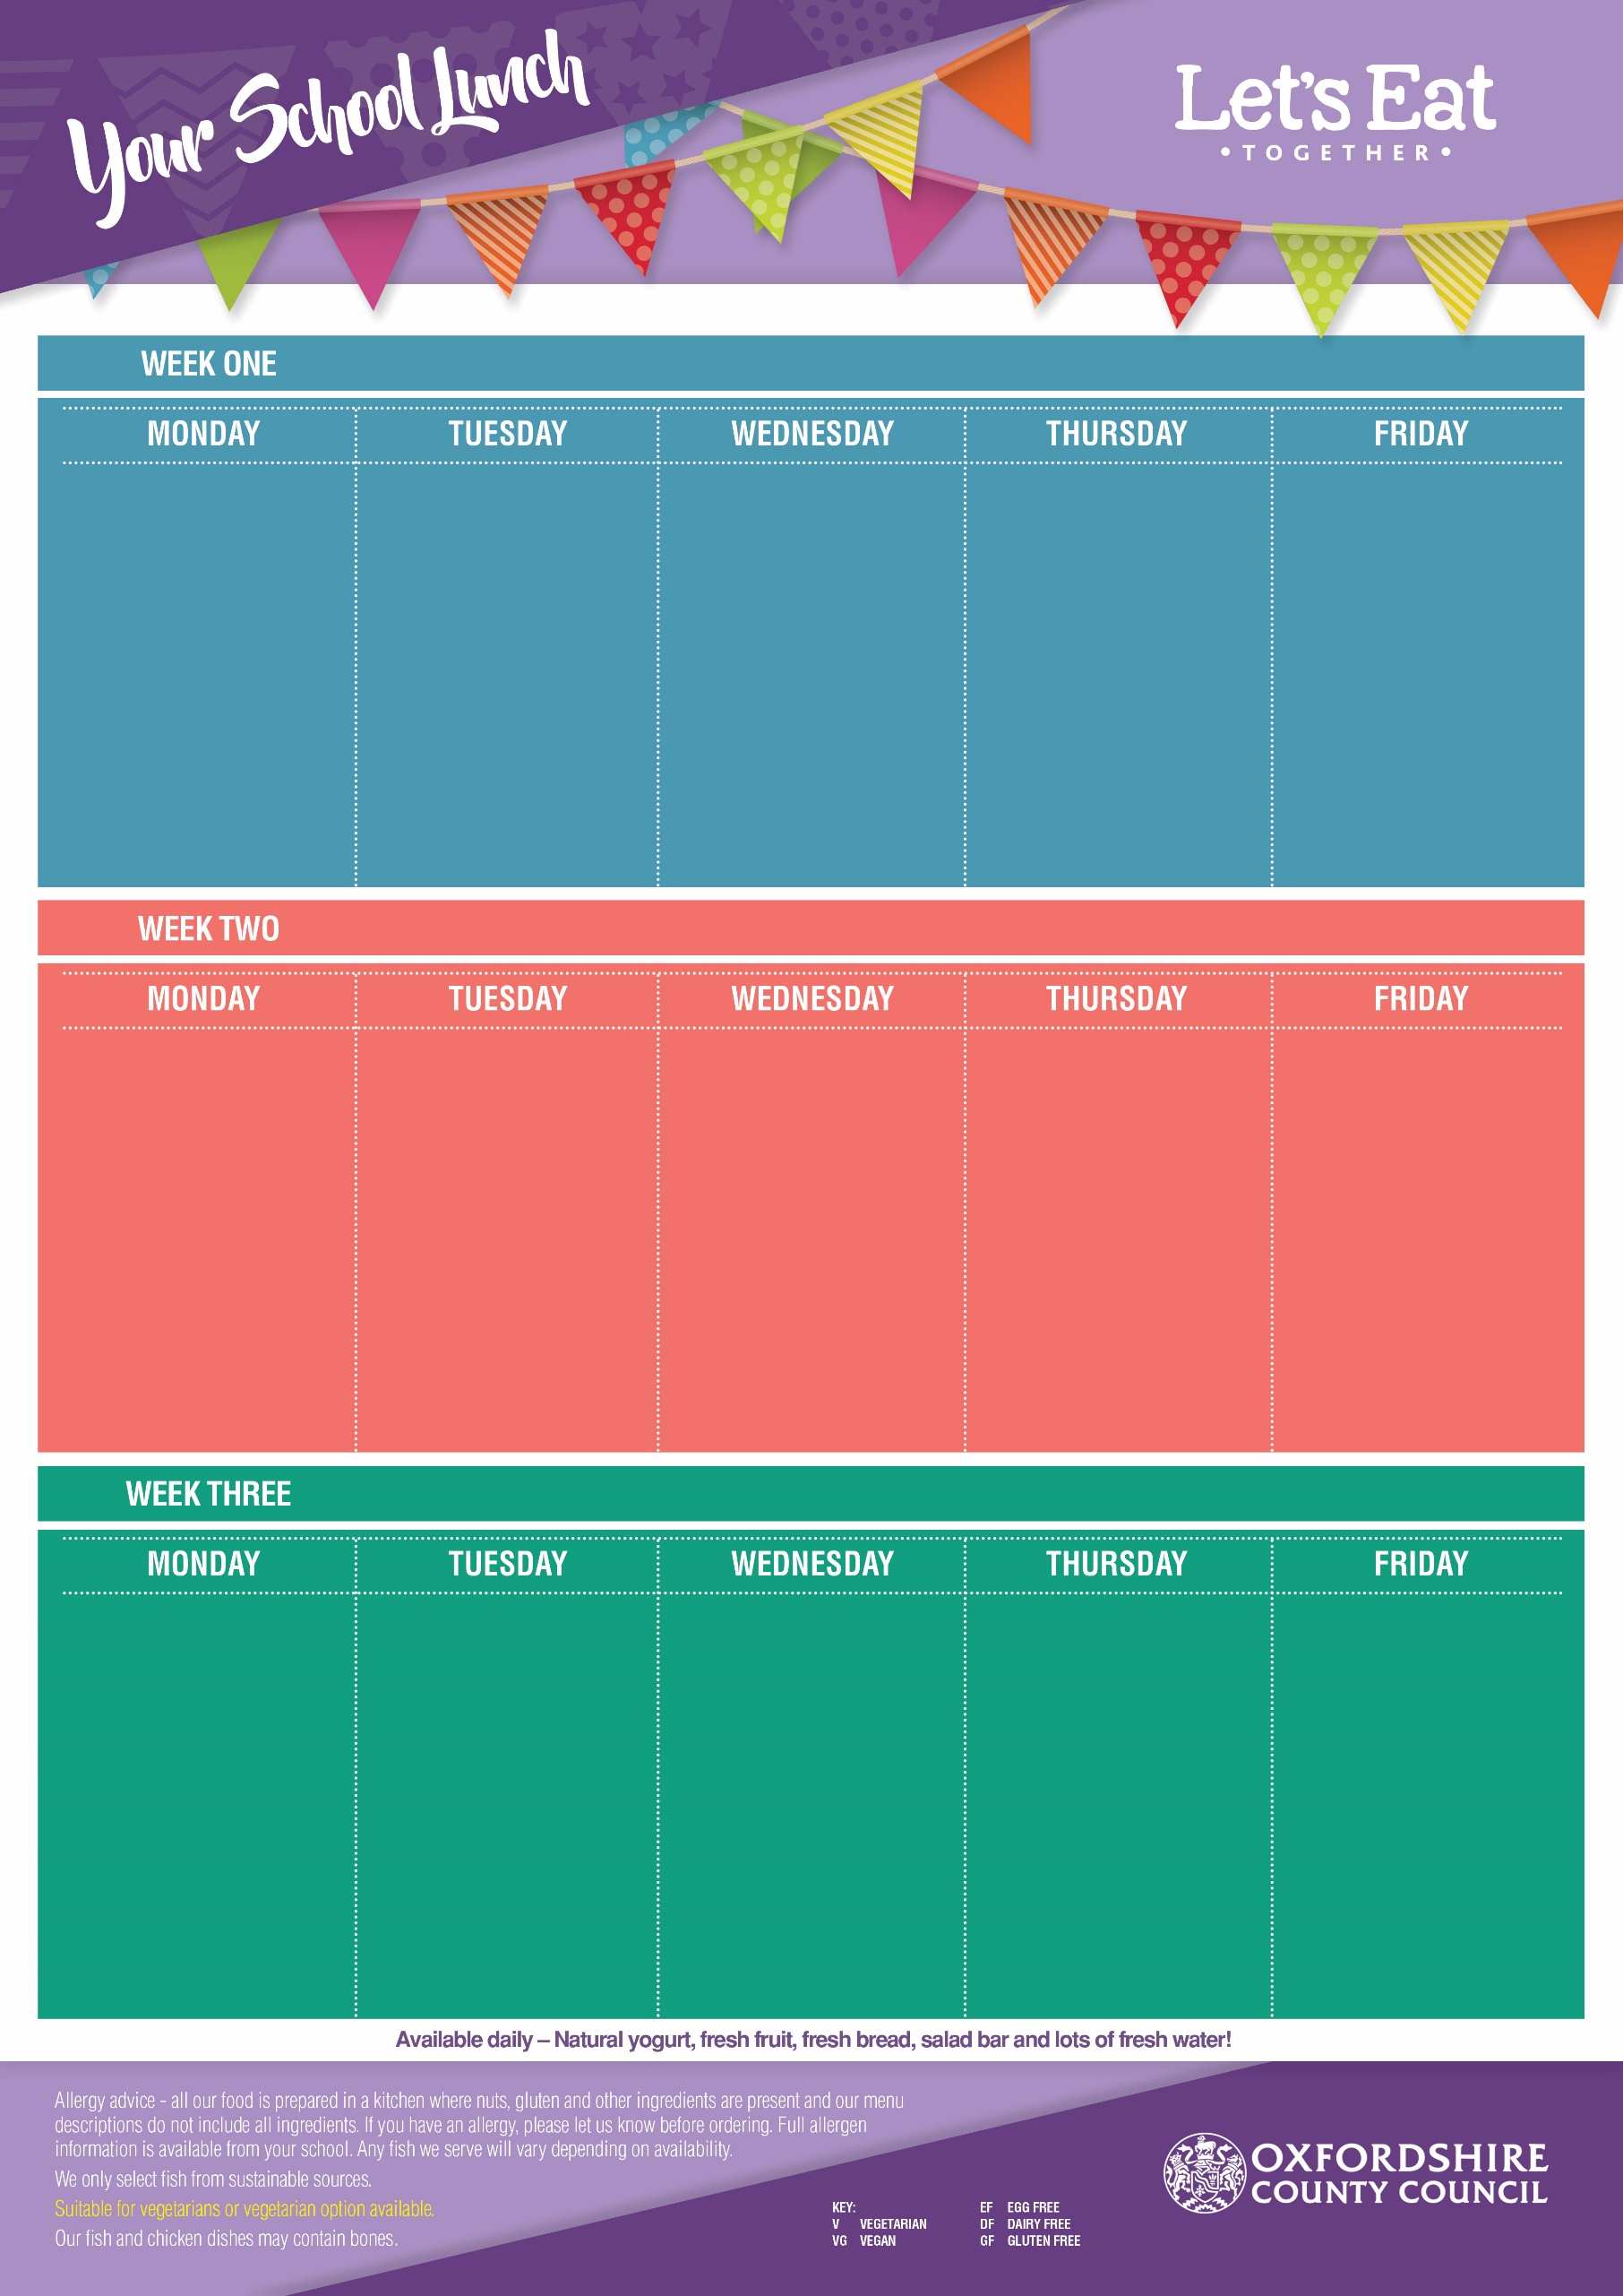
Week Commencing: 16th Nov, 7th Dec, 11th Jan, 1st Feb, 1st March, 22nd March
Week Commencing: 9th Nov, 30th Nov, 4th Jan, 25th Jan, 22nd Feb, 15th March
Week Commencing: 2nd Nov, 23rd Nov, 14th Dec, 18th Jan, 8th Feb, 8th March
Flipper Dippers (DF, EF)
Pizza Pinwheel (V, EF)
Baked Jacket Potato with Cheese (V, GF, EF) or Baked Beans (VG, GF )
Chips or Pasta
Sweetcorn or
Baked Beans

Vanilla Ice Cream
(V, GF, EF)
with Mandarins

Beef Bolognaise with Twisty Pasta (DF, EF)
Veggie Bolognaise with Twisty Pasta (VG,)

Baked Jacket Potato with Cheese (V, GF, EF) or
Baked Beans (VG, GF)

Carrots & Peas

Iced Sprinkle Cake
(V, DF)

Roast Chicken Breast
(GF, EF, DF)
Vegetarian Quorn Roast
(V, GF)

Baked Jacket Potato with Cheese (V, GF, EF) or Baked Beans (VG, GF)
Roast Potatoes & Yorkshire Pudding with Gravy

Cauliflower & Green Beans

Lemon Oat Cookie(V, EF, DF)

Pork Sausages with Gravy (DF, EF)
Veggie Sausage with Gravy (VG, GF)
Jacket Potato with Cheese (V, GF, EF) or Baked Beans (VG, GF)

Mashed Potato, Cabbage & Carrots

Rock Cake (V)
with Melon

Margherita Pizza
(Cheese & Tomato) (V, EF)
Spinach & Potato Curry with Rice (VG)
Baked Jacket Potato with Cheese (V, GF, EF) or Baked Beans (VG, GF
Peas &
Baked Beans

Melting Moment
(V, DF, EF)

Beef Meatballs in Tomato Sauce (GF, DF, EF)
Veggie Meatballs in Tomato Sauce (VG, GF)
Baked Jacket Potato with Cheese (V, GF, EF) or Baked Beans (VG, GF)

Pasta, Sweetcorn & Carrots

Cinnamon Swirl Sponge
(V, DF)

Chicken Nuggets (DF, EF)
Veggie Samosa’s (VG)

Baked Jacket Potato with Cheese (V, GF, EF) or Baked Beans (VG, GF )
French Fries or Pasta
Baked Beans or Peas

Strawberry Jelly
(V, GF, DF, EF)
with Peaches

Cottage Pie
(GF, EF)
Veggie Cottage Pie
(V, EF, GF)
Baked Jacket Potato with Cheese (V, GF, EF) or Baked Beans (VG, GF)

Cauliflower &
Vegetable Medley

Crunchy Cornflake
Cookie
(V, EF, DF)

Sausage Plait (DF)
Crispy Veggie Dippers (VG)
Baked Jacket Potato with Cheese (V, GF, EF) or Baked Beans (VG, GF)

Oven Baked Potato Wedges
Peas & Carrots

Shortbread
(V, EF, DF)
with an Orange Wedge

Margherita Pizza
(Cheese & Tomato) (V, EF)
Mild Mexican Chilli
Loaded Hash Browns
(VG, GF)
Baked Jacket Potato with Cheese (V, GF, EF) or Baked Beans (VG, GF)

Sweetcorn
& Baked Beans
Vanilla Oat Traybake
(V)

Fish Fingers (DF, EF)
Veggie Sausage Roll (V, EF)

Jacket Potato with Cheese (V, GF, EF) or Baked Beans (VG, GF)
Chips or Pasta
Peas &
Sweetcorn
Strawberry Ice Cream
(V, GF, EF)
with Pineapple

Sticky BBQ Chicken
with Rice (DF, EF, GF)
Mac ’n’ Cheese (V, EF)

Jacket Potato with Cheese (V, GF, EF) or Baked Beans (VG, GF)

Broccoli &
Vegetable Medley

Flapjack
(V, DF, EF)
with Raisins
Roast Loin of Pork
(GF, DF, EF)
Quorn Roast
(V, GF)
Jacket Potato with Cheese (V, GF, EF) or Baked Beans (VG, GF)
Roast Potatoes,
Yorkshire Pudding,
Cabbage & Carrots

Chewy Vanilla Cookie
(V, EF)

Cajun Beef & Bean Tortilla (EF)
Cajun Vegetable & Bean Tortilla (V, EF)
Jacket Potato with
Cheese (V, GF, EF) or Baked Beans (VG, GF)

Mixed Salad & Sweetcorn

Lemon Cake
(V, DF)

Margherita Pizza
(Cheese & Tomato)
(V, EF)
Herby Tomato Pasta (VG)
Jacket Potato with
Cheese (V, GF, EF

Peas &
Baked Beans

Ginger
Biscuit
(V, EF, DF)

